Butler Assistive Technology Room Guide for Users
Contents
Contact Information 1
Butler Assistive Technology Room Reservations 2
Butler Room Layout 2
Brief Overview 2
Facilities 2
Equipment 3
Computers 3
Other Equipment 3
Appendix A: Read&Write Quick Start Guide 4
Appendix B: ABBYY FineReader Quick Start Guide 9
Appendix C: Links to Documentation for Additional Assistive Software 13
JAWS (Job Access With Speech) Screen Reader 13
ZoomText 13
Dragon NaturallySpeaking 13
Mac Accessibility 13
SensusAccess 13

Contact Information
Accessing the Room: Located on the ground floor the Van Pelt-Dietrich Library Center near the ADA accessible entrance and the elevators, the Butler Assistive Technology Room’s hours correspond to those of the main library. After confirming your reservation, you can get the combination code for the room at the Van Pelt Circulation Desk located on the first floor. For urgent requests, please stop by the Van Pelt Circulation Desk and ask for assistance.

Technology Support: If you have any questions about technology or need tech help when you use the Butler Room, please contact the Library Technology Services (LTS) Help Desk.
- From 9am to 5pm, call the Help Desk at 215-898-4824 for urgent issues
- For non-urgent issues, or after 5pm, send an email to libhelpdesk@pobox.upenn.edu

Butler Assistive Technology Room Reservations
The Butler Assistive Technology Room (“Butler Room”) is open to all Penn students, faculty, and staff. Reservations may be made for individual bookings, but we will also consider special requests for recurrent or longer bookings.
- Individual bookings can be scheduled for up to four 30-minute sessions per day. These reservations can be made through our self-service scheduler: http://libcal.library.upenn.edu/reserve/butler.
- If you require a longer reservation, please contact us directly via the Penn Libraries Ask Form:
https://faq.library.upenn.edu/ask

Butler Room Layout

Brief Overview
The Butler Room is designed to facilitate and enhance learning. This project strives to explore universal design for learning to consider and appreciate the broad spectrum of human ability. The Butler Room provides a range of accessible technologies to customize learning experience.

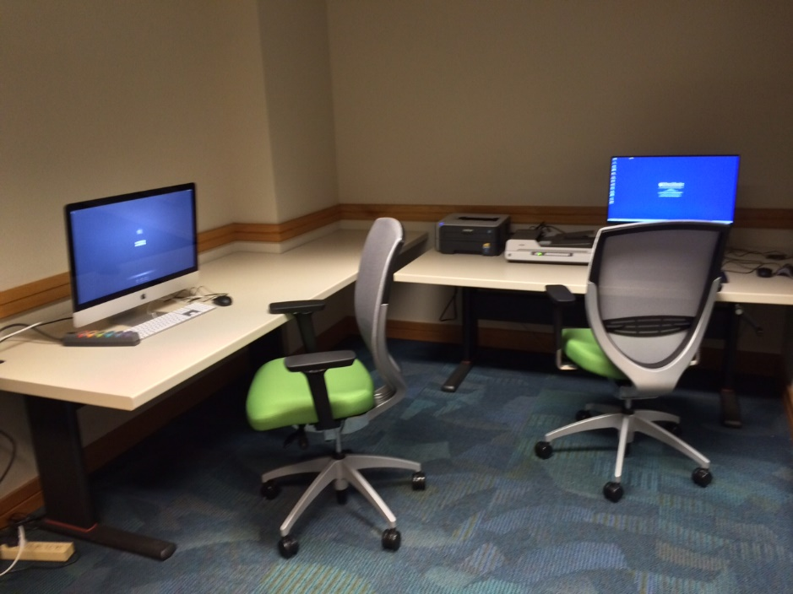
Facilities
The room has several features designed to optimize learning:
- 2 long height-adjustable desks (not moveable)
- 1 long desk (not moveable)
- 2 adjustable dimming desk lamps
- Cabinet for storage
- A variety of technology available for your use while in the room (See Below)

Equipment

Computers
There are two computers available for your use. Below, please find the guidelines on how to access and log on to each computer.

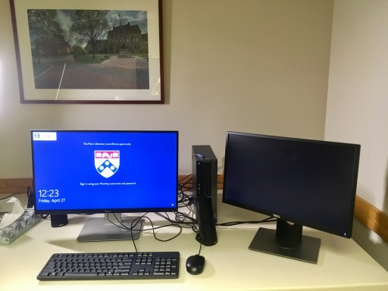 | PC Desktop with Dual Monitors  Located on the right end as you enter the room. The information to log in is as follows.  Username: PennKey  Password: PennKey password
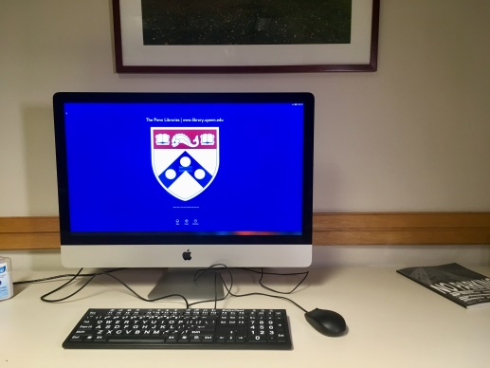 | iMac  Located in front of you as you enter the room. The information to log in is as follows.  Username: PennKey  Password: PennKey password
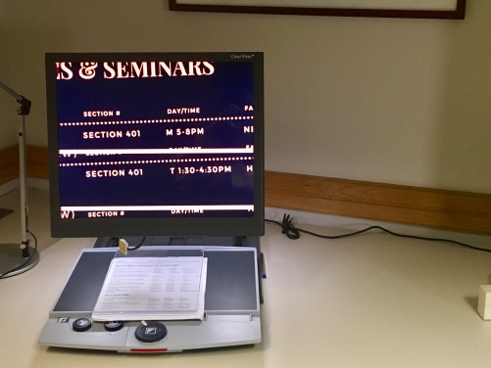 | Video Magnifier  Located to slightly to the left of you as you enter the room. The magnifier requires no log-on credentials to use.

Other Equipment
- A scanner is connected to the PC desktop. ABBYY Finereader is the default scanning software, but you may also use Read&Write or Adobe Acrobat to scan in documents.
- A variety of headphones are available that you may borrow from the Vitale Digital Media Lab, including bone conductive (wireless), on-ear, over-ear (wireless, noise cancelling), and headsets (headphones + microphone).
You can find more information at http://commons.library.upenn.edu/equipment-lending

Appendix A: Read&Write Quick Start Guide


Getting Started: 
To begin using Read&Write, click the Read&Write icon from the desktop. A panel or the Read&Write icon will appear at the top of your screen, making available the functions of the program. You will be prompted to ‘log in’ to your Read&Write account. Qualified Penn students can request an account from Student Disabilities Services (amrou@upenn.edu). If you don’t have a personal account, you can use the Penn Libraries credentials to log in through Gmail:

Username: ButlerPennLib@gmail.com Password: a11y&butler

Please only use these credentials while you are working in the Butler Room.

Tools:
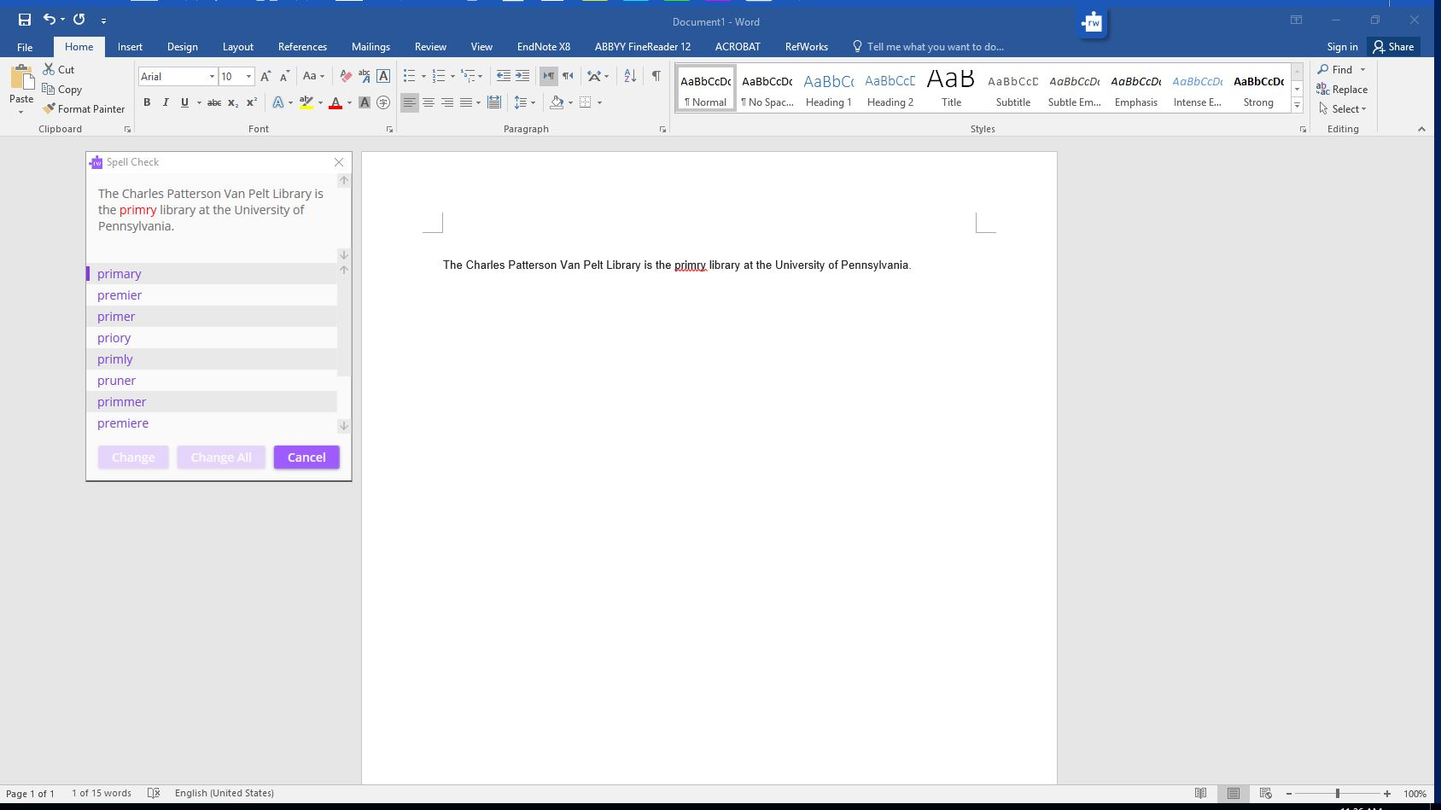
- Spell Check  (Works only on non-online word processors) In any word processor, click the check mark icon to check the accuracy of spelling. If there is an error, a suggestions box appears in the top-left corner to with the misspelled highlighted, offering possible substitutions.

- Prediction 
The prediction function suggests words to the user as they type. After selecting this feature, a suggestion box will appear in the top-left corner, displaying the suggestions.

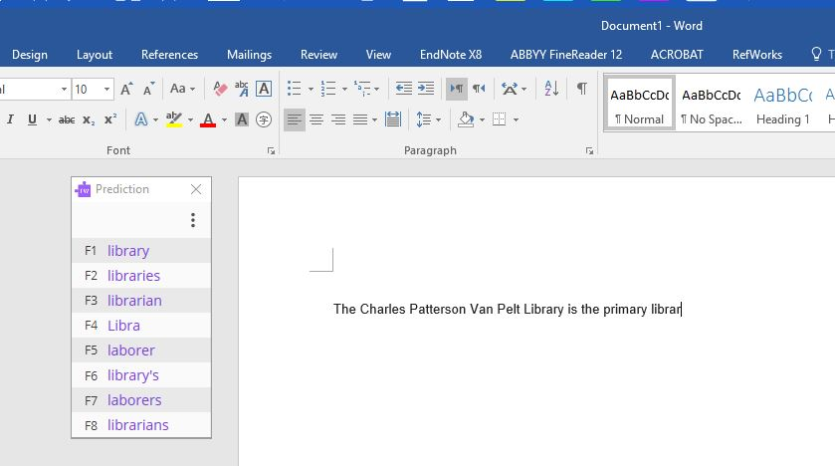
- Dictionary 
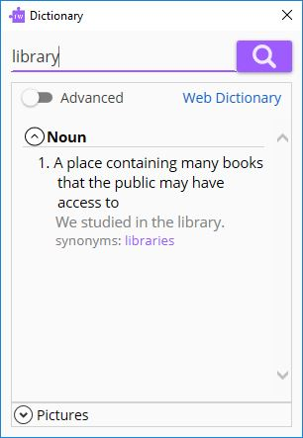
The dictionary function defines a selected word. To use, highlight word of choice, then click on the icon. A dialogue box appears center screen with the definition.

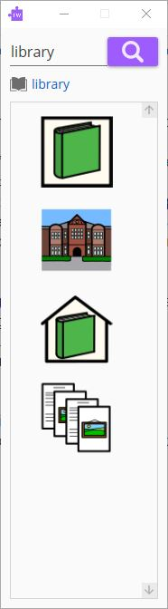
- Picture Dictionary 
The picture dictionary function will search for an image based on a word. After clicking the icon, a dialogue box appears where you type in the word, and it will retrieve an image.



- Play/Pause/Stop - text-to-speech
These functions allow you to play the text on the screen aloud. To begin, highlight a body of text. Then click on the play icon. This begins the text-to-speech recognition. To stop listening, select the stop (square) icon.

- Screenshot Reader 
To use the screenshot reader, select the icon and drag the dashed box over the text you wish to be read aloud. After selection, the program will start reading the text aloud.

- Scanner 
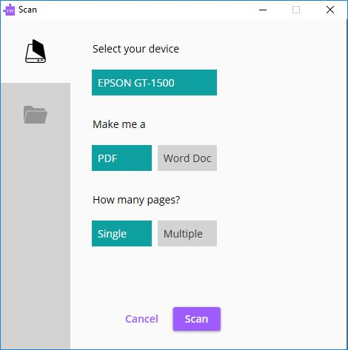
The scanner allows you to scan in documents that can then be read aloud. After selecting the icon, select which device you wish to scan your document or which document you wish to upload. The documents will then be converted using the program’s PDF reader.

You can have the document read to you by clicking on the point icon and highlighting the text you would like to read.


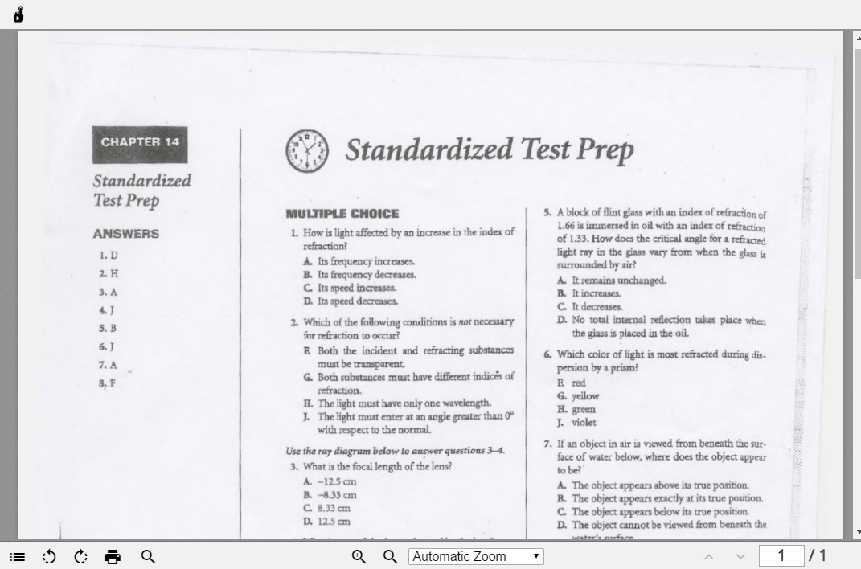

- Highlight – Clear Highlighting – Collect Highlights

To highlight, select the portion of text you wish to color. Then, select your preferred highlighter color. To clear highlighting, click the broom icon. To collect highlighted information, click the circular arrow icon to collect by color or position in document. The selected text will open in a new document.
- Vocabulary List Builder 

Use this tool with Google documents. Sign into your Google account by clicking on the menu icon in the upper-right corner.

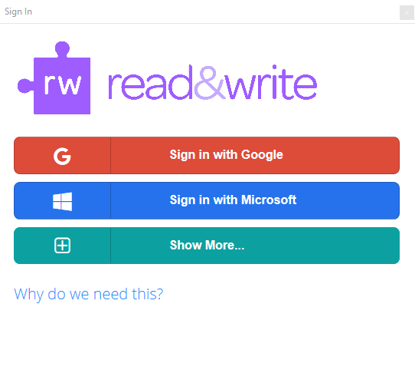
Open a Google document and select words by highlighting them to build a vocabulary list. These words will be created and saved in a new Google Doc.

- Voice Notes 
Record a short (<1 minute) audio clip to insert into a document as a comment. This works in both Google Docs and Microsoft Word documents.

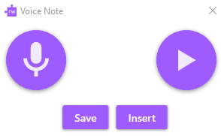

Other Resources:
- Read&Write for Google Chrome – Quick Reference Guide
- Read&Write for Windows YouTube Playlist

Appendix B: ABBYY FineReader Quick Start Guide

What is ABBYY FineReader?

FineReader uses OCR and conversion technologies to help users work better with paper-based documents. Using this application, you can convert PDFs and Scans, edit and comment on PDFs, compare documents, and use automated conversion features.

See the video for further description: https://www.youtube.com/watch?v=xGLGPBON6aE

Convert PDFs and Scans to Word
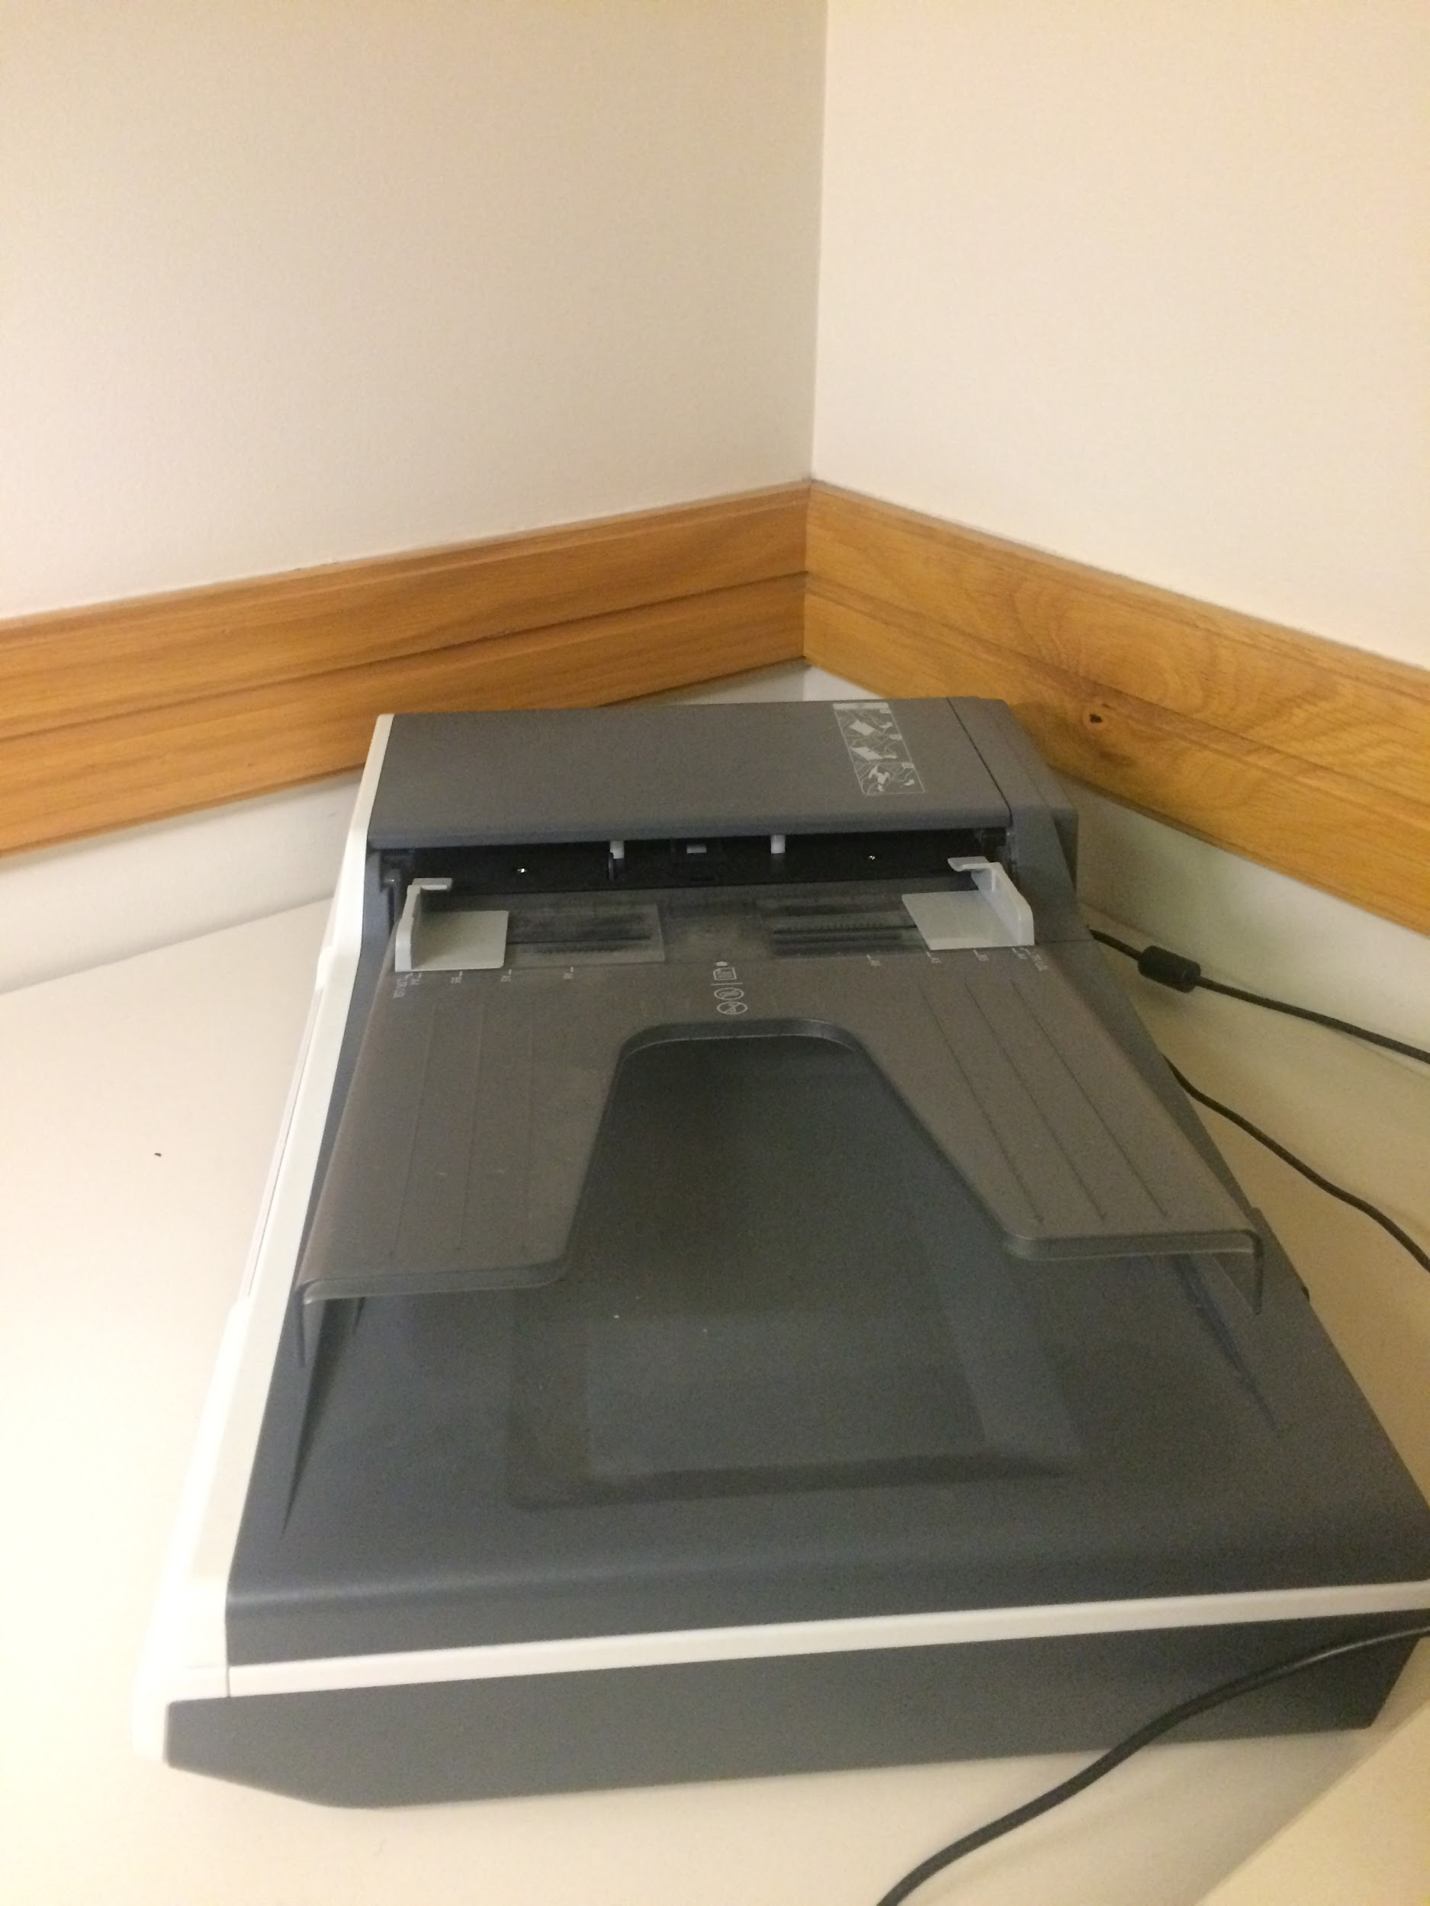
- How to scan?

Scanner is to your left, on the table.

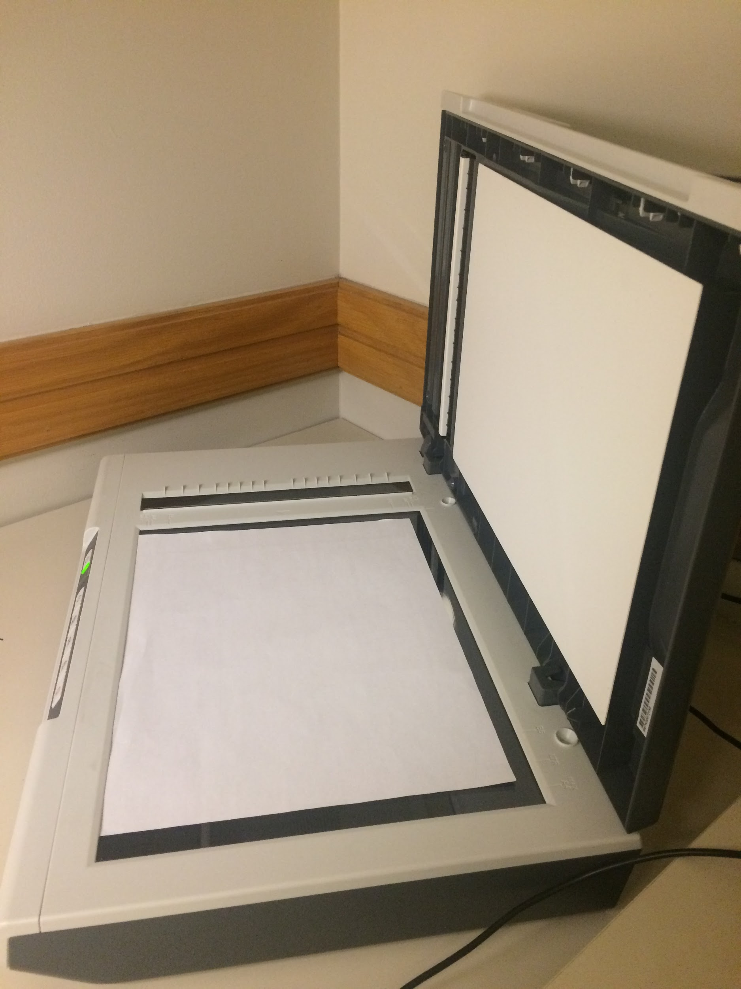

Place the document in the scanner facing down, and then close the scanner again.

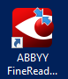

- To open the ABBYY application, click on this red icon.

- Once the application is open, click on the Scan option
from the toolbar menu.
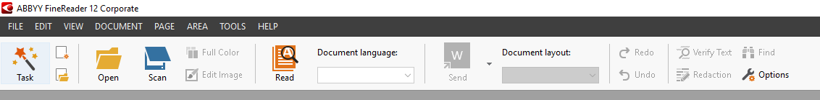
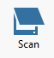

- When you click the scan icon, a new window will pop up asking you to select several settings.
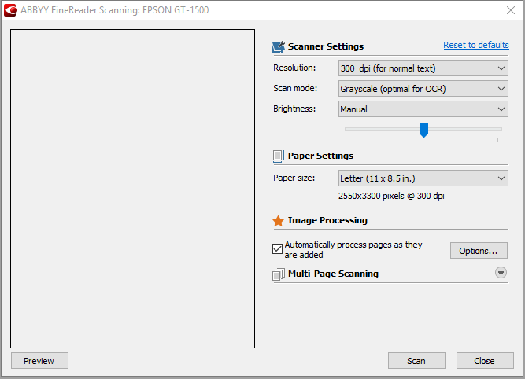

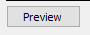
You can also click the Preview button, to see what the scan will look like.
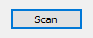
- After you are done selecting all the settings, click scan.

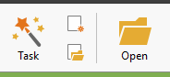
If you already have a pdf that you would like to convert to another type of document, skip all of the steps above, and hit “Open” icon in the toolbar. The select the desired document.

2. How to convert to desired format?
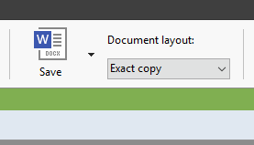
You can choose an option of document layout. Choose “Exact Copy” if you want it to be the same layout as the scanned document.

Before saving the converted file, it is important to go through each page and make sure that everything has been converted correctly.

3. What if the scan was not converted correctly and you want to make some changes?
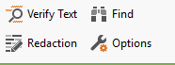
- If the text is incorrect,
click the “Verify Text” button in the toolbar menu.
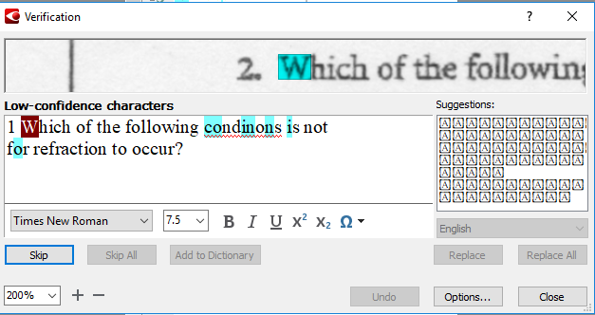

The program will highlight low confidence areas in red, and you can correct them manually.

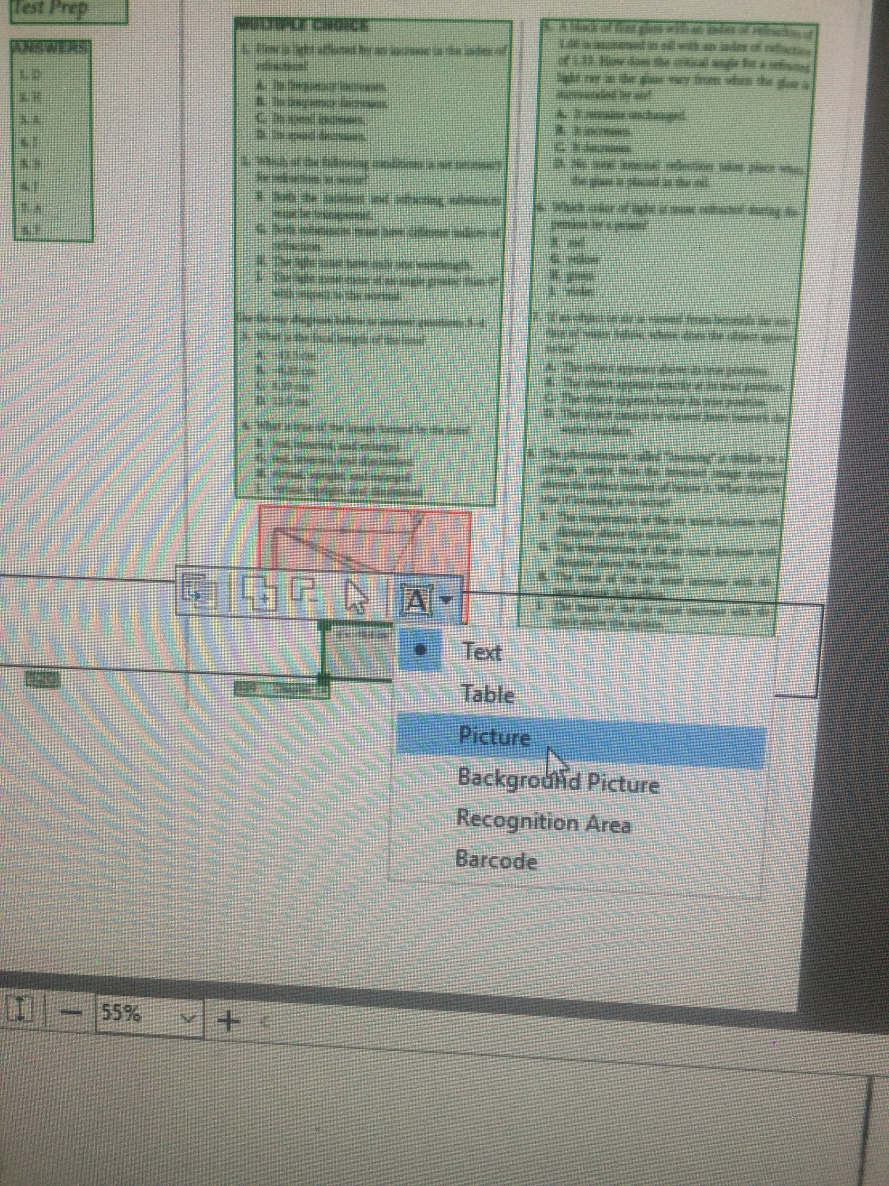
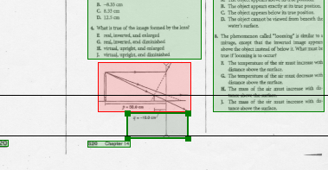
2. If images are transferred as text, the text is located inside the green box, and the image is inside the red box.

- Select the area that was supposed to be an image and put it into the red box as well.
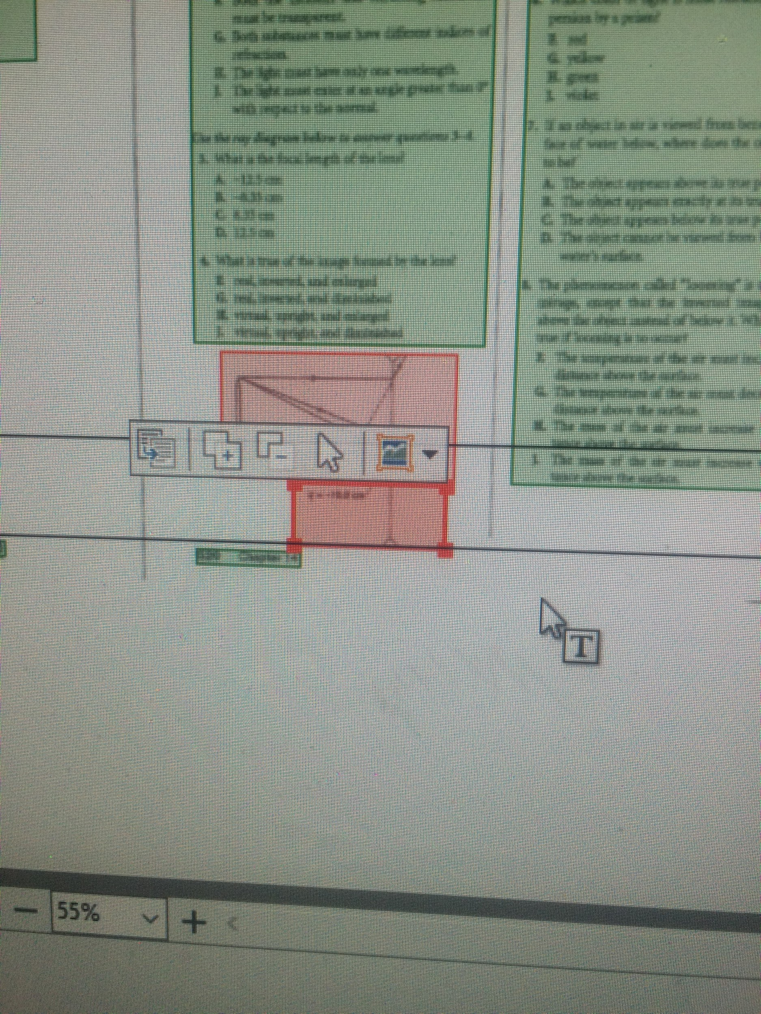

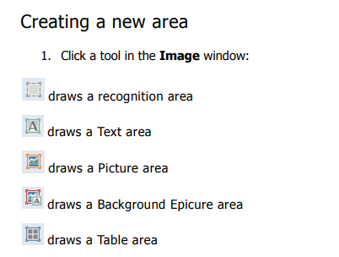

This is a full list of what each icon represents.

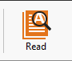
Press “Read” button in the toolbar menu after making changes to make sure that document has been correctly updated

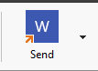
- Once you have made sure that everything seems right, find and click “send” from the toolbar menu.

Appendix C: Links to Documentation for Additional Assistive Software

JAWS (Job Access With Speech) Screen Reader
- Available on the PC
- JAWS 2018 Documentation

ZoomText
- Available on both the PC and Mac
- ZoomText 2018 User Guides

Dragon NaturallySpeaking
- Available on both the PC and Mac
- User guides, cheat sheets, demo videos, and more

Mac Accessibility
Did you know that your Mac has bunch of hidden tools and features that are there to make your user experience even easier?
- To make use of these features, click the Apple icon on the top-left corner, go to system preferences and look for “Accessibility.”
- These programs have good tutorials on their own:
- Apple Mac Accessibility Guide

SensusAccess
SensusAccess is an easy-to-use document conversion tool that can turn PDF files into Word documents, and recognize text in several languages!
- All Penn community members can use the service on or off campus: http://www.sensusaccess.com/web3/upennlib/
- Documentation and user guides

